Required practical activity: Burning Fuels
Practical Guide – Burning Fuels

Aim: Investigate the energy produced by the combustion of various alcohols
Notes and guidance
You may wish to have students collect the equipment for this themselves from communal trays at the front of the lab. This will help them to develop their skills of equipment recognition and organisation. However, if this is impractical, ask your technician colleagues if they are able to set up individual sets at student workstations. Ensure each group has sufficient space to work comfortably.

This practical can be accompanied or preceded by a demonstration of small volumes of these fuels being burned in a watch glass.

If students are working in groups, encourage each member of the group to carry out a trial during the lesson.

Students should take it in turns to use spirit burners filled with different fuels to reduce the number of spirit burners required. Alternatively, groups can investigate one fuel each and compare results at the end of the lesson.

There is likely to be some amount of variation between results from the same fuels between different groups. This is a good opportunity to discuss other variables and errors.

If available, you may wish to provide students with digital thermometers. These can be easier to read and give more precise results. Additionally, if you have access to copper calorimeters, you may wish to use these instead of glass conical flasks.

A particularly advanced class may benefit from discussion and calculation of enthalpy changes of combustion, heat loss, and incomplete combustion, however this is not required at GCSE level.

Risk Assessment Notes
A risk assessment must be completed for this practical. The risk assessment should be specific to the class involved and written only by the teaching member of staff. For more guidance refer to CLEAPSS. It is good practice for students to wear safety spectacles during all class practicals and demos.

Any spillages of these highly flammable alcohols must be reported and cleaned up immediately. Remind your class about the basics of fire safety before this practical.

You may wish to precede this lesson with a less hazardous practical with a focus on Bunsen burner and fire safety in order to assess the class’s trustworthiness around fire and flammable materials.

Methanol is currently classed as highly flammable and toxic. Take care while handling and wear eye protection. For disposal of small amounts, dilute to 1% (v/v) and pour down a foul-water drain with plenty of water or arrange for specialist disposal by a registered waste carrier. Refer to CLEAPSS Hazcard 40b.

Ethanol is currently classed as highly flammable. Take care while handling and wear eye protection. For disposal of small amounts, dilute to 5% (v/v) and pour down a foul-water drain with plenty of water. Refer to CLEAPSS Hazcard 40a.

Propan-1-ol is currently classed as highly flammable and corrosive. Take care while handling and wear eye protection. For disposal of small amounts, dilute to 5% (v/v) and pour down a foul-water drain with plenty of water. Refer to CLEAPSS Hazcard 84a.

Butan-1-ol is currently classed as highly flammable and corrosive. Take care while handling and wear eye protection. For disposal of small amounts, dilute to 5% (v/v) and pour down a foul-water drain with plenty of water. Refer to CLEAPSS Hazcard 84b.

Pentan-1-ol is currently classed as highly flammable and harmful. Take care while handling and wear eye protection. For disposal of small amounts, dilute to 3% (v/v) and pour down a foul-water drain with plenty of water. Refer to CLEAPSS Hazcard 84c.
Equipment Per Group | Equipment Per Group  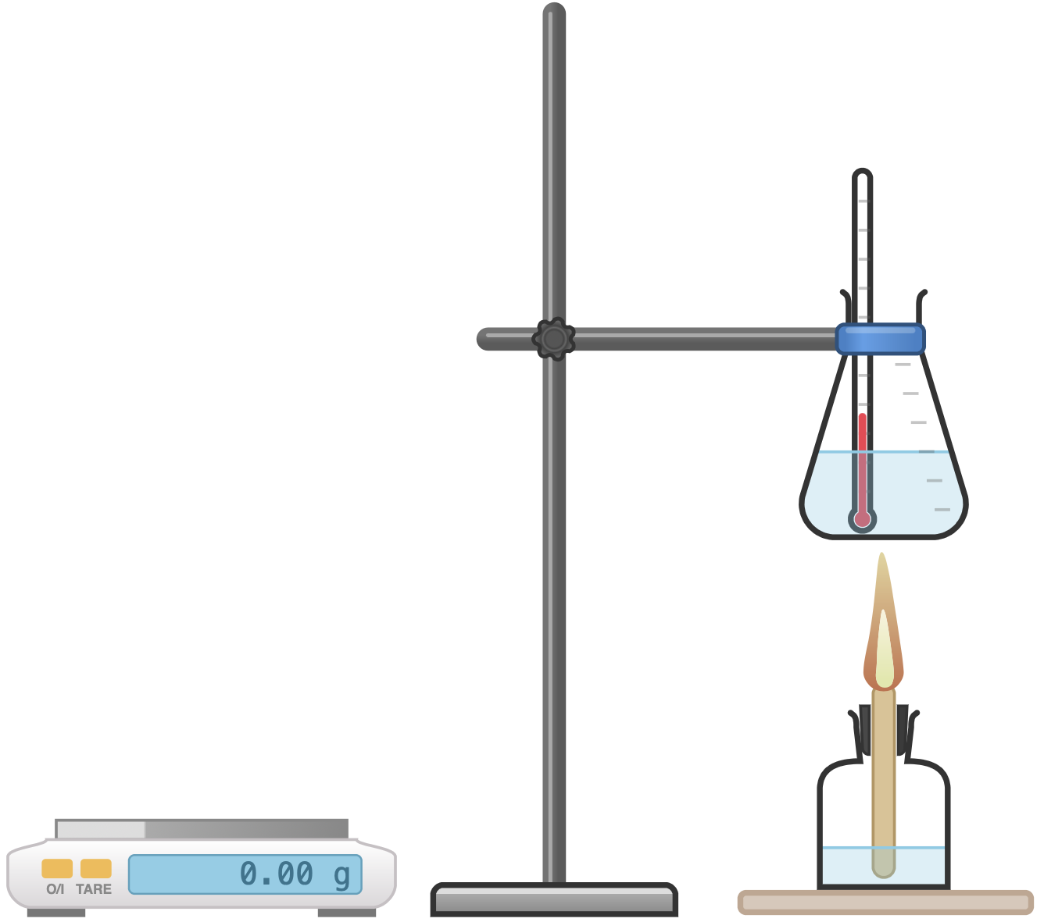
Apparatus:
- Clamp stand
- 250 ml conical flask or copper calorimeter
- 100 ml measuring cylinder
- Thermometer
- Access to a mass balance
- Access to spirit burners with wicks and caps, containing the below alcohols

Chemicals:
- Access to cold tap water
- Methanol
- Ethanol
- Propan-1-ol
- Butan-1-ol
- Pentan-1-ol

Method |  | Questions To Ask Students During The Practical
- Weigh the first spirit burner of alcohol (with cap) and record its mass and the alcohol it contains.  - Place the spirit burner on a heat proof mat.  - Use the measuring cylinder to add 100 ml of cold tap water to the conical flask.  - Use the clamp stand to hold the conical flask a few centimetres above the spirit burner.  - Use the thermometer to measure the initial temperature of the water in the conical flask. Note this temperature.  - Remove the spirit burner’s cap and light the spirit burner.  - When the burning alcohol has heated the water by 40 °C, replace the cap on the spirit burner to extinguish the flame.  - Use the balance to weigh the spirit burner and cap and record its new mass.  - Calculate the mass of alcohol used to raise the temperature of the water by 40 °C.  - Using fresh cold tap water and a fresh, cool conical flask, repeat the above steps with another alcohol. |  | - What would be the advantage of using a digital thermometer rather than an analogue thermometer? (Digital thermometers are more accurate, more precise, and easier to read than analogue thermometers.)  - Why is it important to clamp the conical flask at the same height above the spirit burner each time? (Flames are hotter and colder at different points – a change in height would result in a chance of the amount the water is heated by the burning fuel.)  - Why should we not assume that all the heat produced by combustion goes into heating the water? (Some heat will inevitably be lost to the surroundings and to heating the glass/copper containing the water.)  - Which alcohol produces the most energy per gram of mass? (Pentanol.)  - Which alcohol produces the most energy per mole? (Pentanol.)  - How many carbon atoms do the alcohols each contain? (methanol – 1; ethanol – 2; propanol – 3; butanol – 4; pentanol – 5.)
Alternative Methods/Computer Simulations |  | Clearing up
If dataloggers are available, you may wish for students to use these. These will provide more precise temperature readings than analogue thermometers. |  | It is important that equipment is returned to the prep room in good order. If safe to do so, rinse used equipment and put it in the used equipment tray. If the trays arrived on a trolley, students must return all trays and equipment to that trolley. Anything dirty needs to be placed into a separate container for washing up. Never put dirty equipment back into a tray with clean equipment.  Equipment may be hot after use. If this is the case, leave any hot apparatus to cool down and warn your technician colleague.  Assuming the spirit burners have not been opened or tampered with, alcohols may be saved and reused for future practicals. Refer to CLEAPSS Hazcards for information on the safe disposal of alcohols.
Results Table
Alcohol: | Methanol | Ethanol | Propanol | Butanol | Pentanol
Relative Formula Mass M_{r} | 32 | 46 | 60 | 72 | 88
Mass of alcohol burned to produce 40 °C increase in temperature of 100 ml of water (g)
Energy released per gram of alcohol burned (kJ/g)
Energy released per mole of alcohol burned (kJ/mole)

Technician Notes
Ensure the solutions you provide are free from contamination and the equipment is as clean as possible.

Consult CLEAPSS Hazcards before handling alcohols.

Spirit burners should be small (<50 ml capacity) to minimise the volume of flammable alcohols present in the laboratory. If dedicated spirit burners are not available, a guide to making homemade versions made from small jam jars can be found on CLEAPSS.

Discuss this practical with the class teacher ahead of time. Ensure they have considered the risks of this practical and are confident with the techniques used. If necessary, provide them with the CLEAPSS hazcards (identified in the risk section section above) so they are comfortable with the chemicals to be used and how to use and dispose of them safely.

